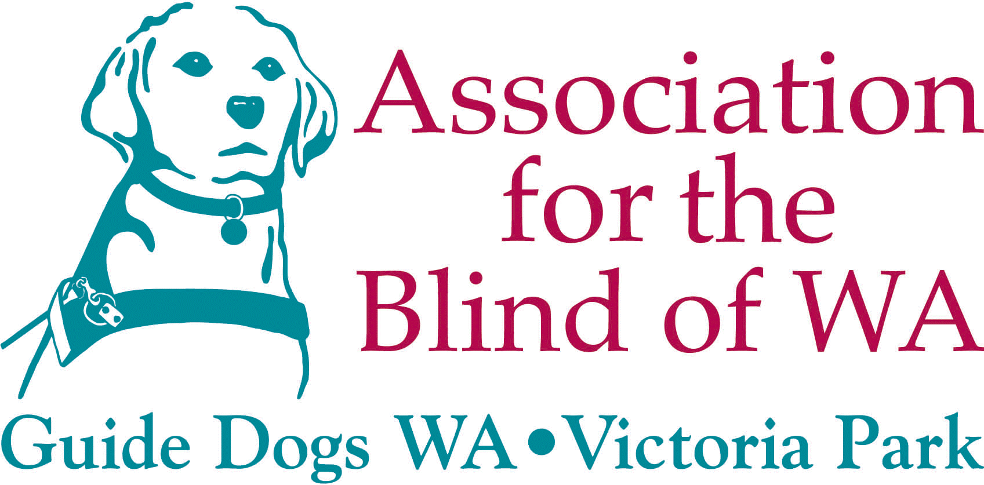

RAILWAY STATIONS

Guidelines for designing safe and accessible stations

for people with vision impairment

1.0 Preamble
  - The Association for the Blind of WA (the Association) is the principal provider of services to people who are blind or vision impaired in Western Australia. Each year the Association provides to its consumers, a broad range of services aimed at maximising their independence in the community.

  - In 1998, the Australian Bureau of Statistics reported that 5,400 people with vision impairment used the public transport system in Western Australia, however a large number (10,600) of people with vision impairment did not use any form of public transport because of problems with access. The main difficulties experienced included accessing stations or stops, and getting into or out of vehicles or carriages due to steps or doors.

  - Most people who are vision impaired are excluded from obtaining a driver’s licence and therefore many rely on the public transport system as their primary method of getting to and from places within the community.

  - The purpose of this paper is to highlight key access features of station design that improve safety and mobility for people with vision impairment.

  - The statements in this paper are the collective views of people with vision impairment regarding station design and draw on their experiences as commuters.

2.0 Access Features
  - The Association strongly supports accesses to stations that accommodate optimum safety features and minimise the distance pedestrians have to travel. At grade pedestrian crossings present significant risks for people with vision impairment and the aged, and are therefore not supported.

  - Clear view or glass lifts are recommended for all stations. Lifts should be constructed from non-reflective materials, which incorporate safety strip markings. Key design features of lifts include: bright lighting; mechanisms that return the lift to either the upper or lower level in the event of a breakdown; and clearly signed and positioned emergency telephones and control buttons which colour contrast with the background and display both visible and tactile legends.

  - Ramp gradients and kerbs for ramps must meet the minimum requirements as determined in the Australian Standards 1428.1; non-slip materials must be used on all ramps and footbridge surfaces; the width of ramps should allow people with guide dogs or prams to pass comfortably.

  - Stairs must be well lit at all times and straight wherever possible. Risers should be enclosed to avoid over stepping and of an adequate depth (ie toe to heel). Surfaces should be non-slip and the edges of each step must be marked for visibility when descending or ascending.

2.5 Underpasses that are fully enclosed and dark have the potential to attract anti-social behaviour. An open design plan and use of bright lighting and strong contrasting colours are recommended to enhance safety and security.

2.6 Island platforms are the preferred method of boarding trains amongst the majority of people who are blind and vision impaired in WA. A simple design layout in the form of a single platform reduces the propensity for confusion and anxiety and enables assistance from other commuters and Station Guards to be more readily available.

  - Pathways to platforms, ramps, stairs and all station waiting areas should be fully sheltered to protect patrons from harsh weather conditions. People with vision impairment walk slower than sighted patrons and are not inclined to run to escape adverse weather conditions.

2.8 Handrails must be provided on ramps, stairs, in lifts and at the entry and exit to stations and should be provided on both sides of access pathways. The entire length of the handrail must provide a luminance contrast and incorporate texture changes and raised symbols to provide additional information, for example, to indicate the top or bottom of ramps, or warn users they are approaching a right angle corner.

2.9 On many stations significant gaps exist between the platform and the train making boarding and alighting difficult. To enhance independent access, station design should comply with the Disability Standards for Accessible Public Transport – Clause 8.2 Boarding.

3.0 Information
  - Information such as timetables, route maps and fares must be available to people with vision impairment in a format they prefer.

  - Audible timetables located on the station are preferable, however large print, Braille and electronic formats should also be made available.

  - Audible timetables must be appropriately marked with both raised letters and large print to identify what information they provide. Information must announce what side of the platform is designated for particular routes, whether the train stops all stations or express, and where the train terminates.

  - Audible timetable machines, ticket machines, telephone and information stands should all be positioned in one area preferably against a wall. Each machine should have a single purpose and should be clearly marked with visible and tactile legends.

  - Announcements on trains should indicate the next scheduled stop and include the direction from which passengers should alight, that is either left or right.

  - Personal address systems on stations should indicate on which platform the train is arriving, its destination, whether the train stops all stations or express, and where the train terminates.

4.0 Signage
  - The location of signs must be at eye level to enable people with vision impairment to get as close to the sign as possible. Where possible signs should be positioned on building walls, signs on poles or posts must be set back from the pathways as these can become a hazard for people who are vision impaired.

  - Signs need to be consistent, clear and concise and must display both visual and tactile formats. The use of audible sign posting with up to five minutes of audible information should be investigated.

  - Strong colour contrasting of signs is essential. Signs should be well lit, and use non-reflective materials to lessen the effect of glare.

5.0 Security Features
  - Station guards, emergency telephones, bright lighting and video surveillance cameras are important safety and security features and should be provided on all stations. Station guards and other railway staff should be appropriately trained to provide assistance to people with disabilities.

  - Emergency telephones must be clearly distinguishable by providing a luminance contrast and clear signage. Instructions for use must be provided in visual and tactile formats.

  - To alleviate the difficulty consumers have with locating doors; voice feedback mechanisms should be investigated. Another alternative is to have the doors open automatically when the train arrives at the station.

  - Barriers between the rail carriages and barriers on the edge of platforms are considered features requiring further investigation. Blind Citizens Australia has suggested fitting a chain linkage between carriages at an appropriate height to enable long cane users to distinguish between carriage doors and the gaps between carriages.

6.0 Tactile Ground Surface Indicators
  - Tactile ground surface indicators are considered an extremely helpful method of assisting people who are blind or vision impaired to find their way around stations and surrounding areas.

  - Tactile ground surface indicators are effective on the platform edge, and at the top and bottom of stairs and ramps. To maintain consistency of tactile treatments throughout the rail network the Association recommends that the Department of Transport refer to the Australian Standard 1428.4.

  - Tactile treatments should also be provided to assist people with vision impairment to access station machines, including the info-line, the emergency telephone and timetable information.

7.0 Luminance/Colour Contrast
  - The use of suitable colours can provide a luminance contrast that allows a person with vision impairment to more easily locate structural features on stations including doorways, pillars, and station furniture. A 30% luminance contrast is recommended by the National Centre for Ageing & Sensory Loss.

  - Contrast lines assist people with vision impairment to find their way around stations and surrounding areas. The lines are helpful guides on pathways, for locating train doors and the edges of platforms. They should be maintenance free to prevent wear and tear.

  - Train driver training to highlight the importance of aligning train doors to contrast markings on the platforms should be provided on an ongoing basis.

8.0 Station furniture
  - The positioning of station furniture requires special attention at the design stage. Seating, sign posts and garbage bins must be placed away from the path of travel to avoid them becoming obstacles and must provide a strong luminance contrast.

  - The design of station furniture should be such that the main body is solid and reaches the ground. Furniture with legs or slats incorporated into the design can be hazardous as canes may get caught between them.

  - Grabrails, bollards, and deterrents used to control bike riders and skaters are considered hazardous as they produce obstacles. It is recommended that they only be used in extreme circumstances. Colour contrasting and laying warning tactile ground surface indicators will help people with vision impairment locate their presence.

9.0 Lighting and Surface Materials
  - People with vision impairment generally require up to double the quantity of light needed by sighted people. Buildings and surrounding open areas must therefore be well lit.

  - Reflection and glare from shiny surfaces cause visual confusion and should therefore be kept to an absolute minimum or avoided altogether.

10 July 2002

Dr Margaret Crowley Date

Chief Executive Officer

